Technical Datasheet Input / Output Modules with Modbus RTU Protocol with RS485 Interface

The IO modules communicate via RS485. The port can drive distances up to max 700 meters without the use of any repeater (this feature however also depends on the signal strength of the Modbus Master Device).
The RS485 Digital IO module is sturdy, has low power usage and is easy to use.

4 Port DI Module: -
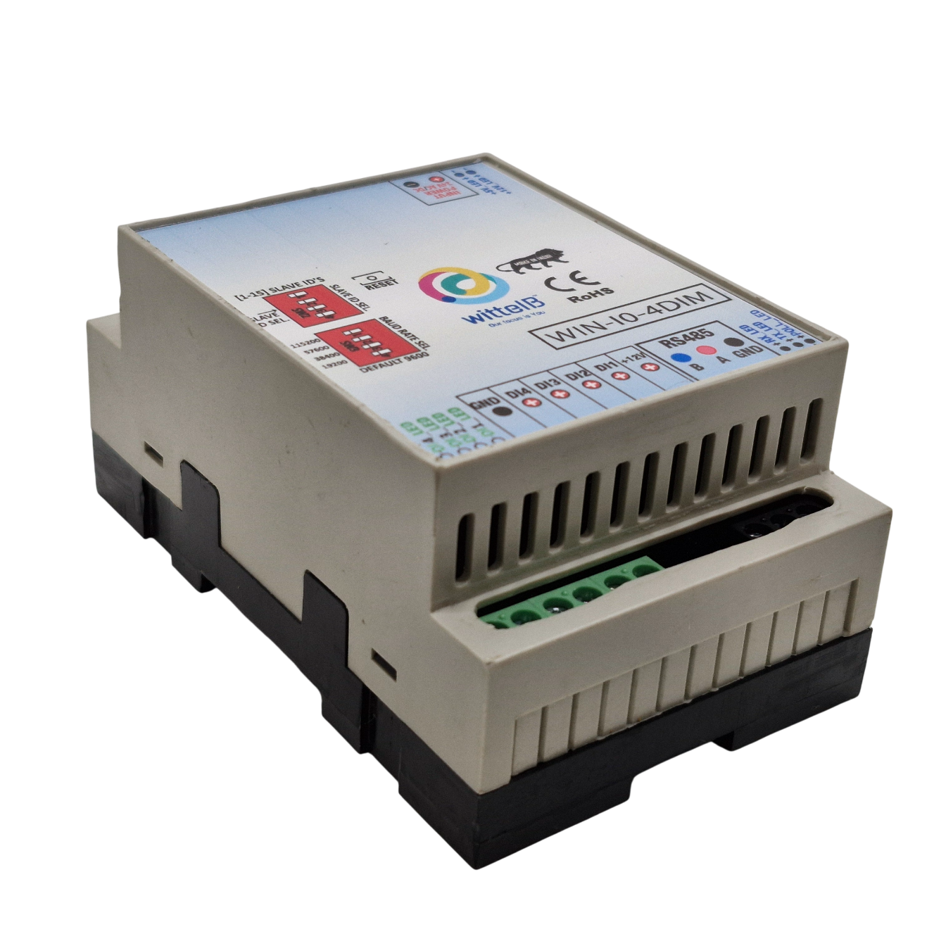
The IO modules are mounted on DIN rail mountable casing and with exposed connectors and LED indicators.

The design of the modules incorporates ‘resettable Fuses’ to safeguard against reverse polarity connection both for Power and Communication port.
Specifications
General –
I/O Connectors 2 Pin 5.08 mm pitch pluggable screw Terminal Block
Dimensions 60 mm L x 110 mm B x 50 mm H
Power Input Power – 12 – 24 VDC or 24 V AC/DC
Typical – 12V DC @ 80mA
Operating Temperature 0 – 60° C (32 ~ 140°F)
Storage Temperature -20 - 70° C (-4 ~ 158°F)
Storage Humidity 5 ~ 95 % RH, non – Condensing
Certifications 

DI Inputs –
Channels 4
Sense Voltage 3.3 – 30 VDC
Sense Logic Logic ‘0’ = <1 VDC, Logic ‘1’ = >3.3 VDC
Isolation Optically isolated
Response Time 2 msec, Max 6 msec

Additional Features: -
All inputs and communication port isolated
Input power reverse polarity safety
ESD Safety IEC 61000-4-2, ± 30KV contact, ± 30KV air
EFT IEC 61000-4-4, 50A (5/50ms)
750V isolation.
CRC Error check.
No configuration needed on the IO board

Configuration Settings: -
Communication Speed 9600 – 19200 Kbps (DIP SW selectable)
Data Bits 8
Parity None
CRC Yes
Stop bit 1
Slave Id Soft Setting.
Function code DI 0x02 Read discrete Input
DI Register Address 0,1,2,3.
Function code For Soft Serial 0x03 Read Holding Register
Soft Serial Register Address 10,11,12,13,14,15,16,17.

ID | Function  Description | Register  Description | Modbus Function Code | Protocol | Data  Type
0 | DI 1(With & Without Potential) | 10001 | 0X02 | RS485 | 1 Bit Boolean
1 | DI 2(With & Without Potential) | 10002 | 0X02 | RS485 | 1 Bit Boolean
2 | DI 3(With & Without Potential) | 10003 | 0X02 | RS485 | 1 Bit Boolean
3 | DI 4(With & Without Potential) | 10004 | 0X02 | RS485 | 1 Bit Boolean
4 | Display Baud Rate (Default:960) | 40011 | 0X03 | RS485 | 16 Bit Unsigned int
5 | Enter New Baud Rate | 40012 | 0X03 | RS485 | 16 Bit Unsigned int
6 | Display Slave ID (Default:1) | 40013 | 0X03 | RS485 | 16 Bit Unsigned int
7 | Enter New Slave ID | 40014 | 0X03 | RS485 | 16 Bit Unsigned int
8 | Display Parity  (Default: None-3, Odd-1, Even-2) | 40015 | 0X03 | RS485 | 16 Bit Unsigned int
9 | Enter New Parity | 40016 | 0X03 | RS485 | 16 Bit Unsigned int
10 | Display Stop Bit  (start-2/stop bit-1) | 40017 | 0X03 | RS485 | 16 Bit Unsigned int
11 | Enter New Start/ Stop Bit | 40018 | 0X03 | RS485 | 16 Bit Unsigned int

- In register 40015- you will able to see the current parity and you can change it in register 40016
- In register 40017- you will able to see the current stop bit and you can change it in register 40018
- If you want to enter the baud rate 9600/19200/38400/57600/115200etc.
Enter it as 960/1920/5760/11520etc.
- After that press the reset button or reboot the system.

BAUD RATE and SLAVE ID DESCRIPTION:
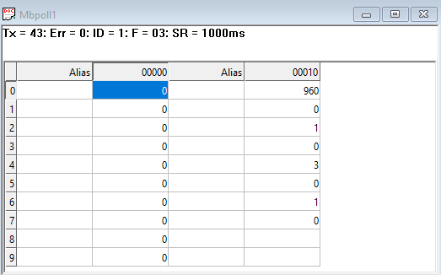
As you can see in the image above, the resistor 40011 – 960 represents the present bund rate (9600) of the board and 40013 – 1 represents the present slave id of the board.

To change the baud rate and slave id you have to enter a value on the 40012 resistor for the baud rate and 40014 for the slave id as shown in the image below.
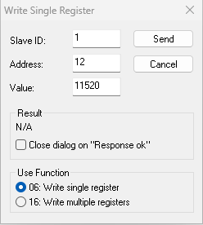
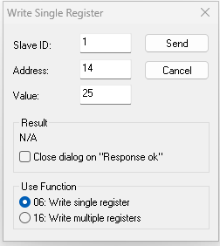

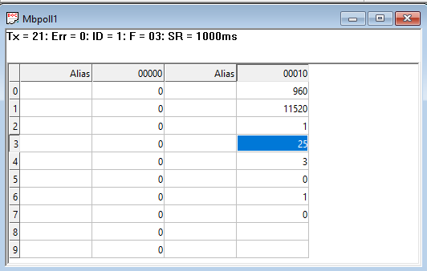

As you can see in the image above I set 115200 baud rate and slave ID 25.
Note:
1. If you want to enter the baud rate 9600/19200/38400/57600/115200etc.
Enter it like this 960/1920/5760/11520etc.
2. After that press the reset button or reboot the system.
3. Then you will get the present value of 11520 at 40011 baud rate(115200) and 25 at 40013 slave id.
4. You can Change Parity Bit , stop bit Of the device with same way.

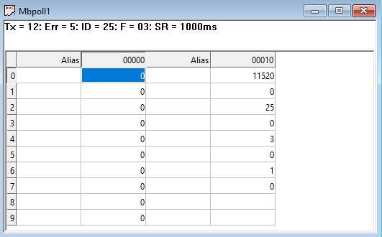

For MODBUS communications, a shielded and twisted pair cable is used. One example of such cable is Belden 3105A.

Recommended Cable Electrical Characteristics: -
22 AWG Cable Shielded and twisted pair
Tinned Copper Recommended
Nominal Conductor DCR 14.7 ohm / 1000 ft
Nominal Capacitance 11 pf / feet (conductor to conductor)
High Frequency Non-Insertion Loss 0.5db / 100

Soft Setting Description

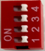
Default Setting for Dip Switch

NOTE – By default the Jumper setting on the board is 10 V and 10 Bit.
– By default, Baud rate DIP Switch 1 is set to ON, toggling it OFF and
Pressing reset button will bring the device to default RS485
Configuration i.e. Baud rate - 9600, Stop bit - 1, Parity - None,
Data Bit - 8. Keep the indicated DIP switch to ON position for
Setting desired configuration.

DI

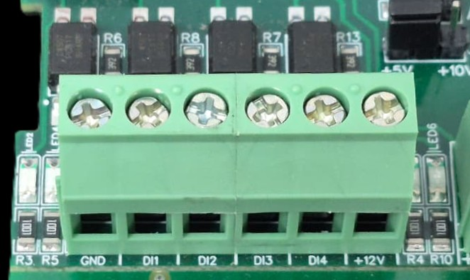

I/p device
I/p device
I/p device

I/p device

- Operation: The module provides four isolated input channels (DI1–DI4) for sensing external signals or dry contacts. These inputs are opto-isolated for circuit protection.
- Terminal Layout:
  - GND: Common Ground reference.
  - DI1 – DI4: Individual Digital Input channels.
  - +12V: Internal reference voltage for sourcing "Dry Contact" switches.
- Wiring Options:
  - Dry Contact: Connect a switch between the +12V terminal and any DI pin.
  - External Voltage: Connect the external signal to a DI pin and the external ground to the GND terminal.
- Voltage Rating: The input circuitry is rated for a maximum of 80VDC. Ensure external signals do not exceed this limit to prevent damage to the isolation ICs.

For Digital Input with Potential (3V to 30V) Contact + Common GND terminal should be connected on the Board, e.g DI1 +ve terminal and GND pin.
1 2 3 4
DI +ve Pins
Common
GND
Input
12 V DC
Modbus
RS485
Input
12-24 VDC
Default Setting Dip Switch
Reset Button

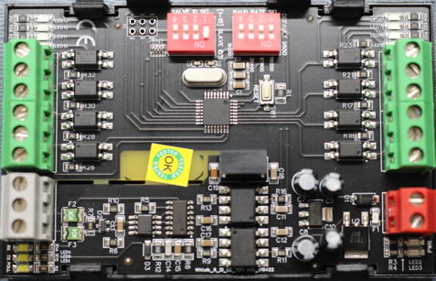

Contact Information
Augmatic Technologies Pvt. Ltd.,
Plot no 6, Shah Industrial Estate II,
Kotambi,
Vadodara – 391510.
Email – Sales@wittelb.com
Support E.: support@wittelb.raiseaticket.com / M.: 9403892805

